CardPay Trust score

What is a Trust Score?

Each time a consumer gives a company a review between 1 and 5 stars we recalculate the overall TrustScore. This calculation is based on all reviews that the company has collected so far and uses the following three key factors: time span, frequency, and Bayesian average.

what is meant by Time span?

The most recent review counts and weighs the most, as new reviews give you more insight into your current customer satisfaction than old reviews.The TrustScore takes this into account by giving less weight to old reviews and more weight to new reviews. For example, a review received 6 months ago has half the weight of a review received today.

what is meant by Frequency?

We recalculate the TrustScore every time a new review is posted. The more frequently you collect reviews the more stable your TrustScore will be. For example, a company received twenty 5-star reviews two years ago and therefore has a TrustScore of 4.5. If they were to receive one 1-star review today, their TrustScore would drop to 3.4.

what is meant by Bayesian average?

We use a Bayesian average in the calculation of the TrustScore to ensure that a company with few reviews starts off with a more balanced average TrustScore, instead of an extremely high or low score based on only a low volume of reviews. This means that in all TrustScore calculations we automatically include the value of 7 reviews worth 3.5 stars each. As the company collects more reviews this becomes a smaller factor in the calculation of the overall TrustScore.For example, if a company receives a single 1-star review, its TrustScore would be 3.2 stars rather than 1-star.This also explains why a company that only has 5-star reviews can have a TrustScore of 4.5 instead of 5.

What Is Trust Flow?

Trust Flow is a score between 0 and 100 based on a website’s quality.Trust Flow is a metric trademarked by Majestic that analyses how trustworthy a site is by measuring its quality.Quality is the essential data of this metric. If a link pointing to your website is authoritative and qualitative, then your trust flow will increase.

What is Citation Flow?

Citation Flow is a metric trademarked by Majestic that refers to the popularity of a link in a site without considering the quality of these links.A website with a lot of links pointing to it will be influential and will get a good citation flow.

From TrustScore to star rating

After the calculation, the TrustScore is then visualized into the overall star rating.Using standard mathematical rounding rules, the star rating will be rounded up or down to half or full stars, depending on the calculation of the TrustScore.For example, if your TrustScore is between 4.3 and 4.7, it appears as 4.5 stars.We will Ask all our customers to leave reviews Satisfied customers often just need a little reminder to leave their positive review. By asking all your customers for feedback, you’re also interacting with them and showing that their opinions matter to you. Remember to reply to their reviews as well to show an even higher level of care and engagement.

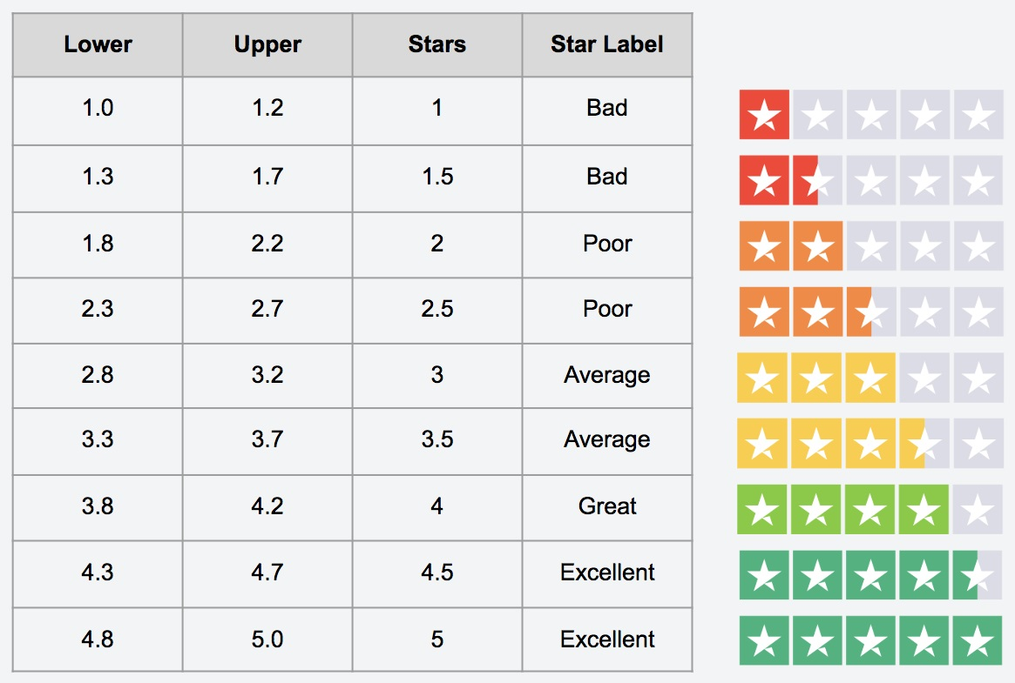

We Learn from all our reviews

We collect, manage, and analyze reviews, calculate trust score. So our merchant companies can learn from them and improve where necessary. This goes for both positive and negative reviews.

Formulae for calucating rating

W1 is the weight for new review.Where as W2 as is the weight of the total reviews excluding the new review.where T.F is Trust Flow and C.F is Citation Flow. W1= 0.70 and W2=0.30. T.F + C.F is constant for a website.75% of the rating depends on user reviews and 25% of rating is based on Website quality.

total =(W1.new+W2.total)3/4+((T.F+C.F)/40)1/4

What is minimum card trust score?

Minimum Card trust score for a merchant website should be more than 3.5 stars then we will consider it has trustworthy website.Reviews will be taken from verified customer who has registered in our application and also done transaction in merchant website.